**Lab 01 – Single-row Functions**

**Lab Due:**

***Please show your lab1 answers during your lab period.***

***Please ensure your file runs when the entire file is executed in SQL Developer.***

Create a new Worksheet in SQL Developer. Save the file as Lab1.sql

## **Style Guide**

Your SQL should be written using the standard coding style:

* all keywords are to be upper case,
* all user-defined names are to be lower case, (example: table and field names)
* there should be a carriage return before each major part of the SQL statements (i.e. before SELECT, FROM, WHERE and ORDER BY)

See the following sample:

**SELECT** columns

**FROM** tables

**WHERE** conditions

**ORDER** **BY** column1, column2;

**Tasks**

**For each question, the title of columns and the output result must match the provided output result in that question.**

-- **Q1:** Write a query to display the tomorrow’s date in the following format:  
 January 10th of year 2019  
the result will depend on the day when you RUN/EXECUTE this query. Label the column “Tomorrow”.  
  
***Advanced Option*:** Define an SQL variable called “tomorrow”, assign it a value of tomorrow’s date and use it in an SQL statement. Here the question is asking you to use a Substitution variable. Instead of using the constant values in your queries, you can use variables to store and reuse the values.

**See the following example:**

**select \***   
**from employees  
where employee_id = 107;**

**You can also have the following code:**

**define emp_id number = 107;  
select *  
from employees  
where employee_id = &emp_id;  
After you use the variable, you can undefined the variable:**

**undefine emp_id;**

**Define a variable of type datetime:**

**define tomorrow = sysdate + 1;**

-- **Q2:** For each product in category 2, 3, and 5, show product ID, product name, list price, and the new list price increased by 2%. Display a new list price as a whole number.

In your result, add a calculated column to show the difference of old and new list prices.

Sort the result according to category ID first and then based on product ID.

You output must match the following result. This result is partially displayed as it has 158 rows.

See the result for the first 10 rows.

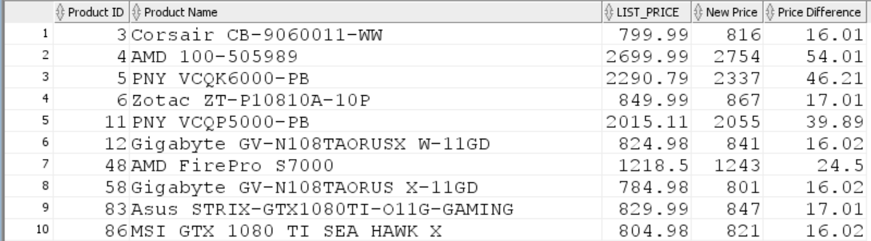

-- **Q3:** For employees whose manager ID is 2, write a query that displays the employee’s Full Name and Job Title in the following format:

Summer, Payne is Public Accountant.

Sort the result based on employee ID.

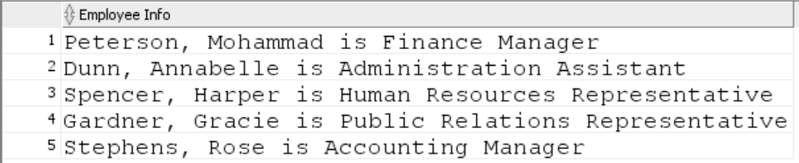

-- **Q4:** For each employee hired before October 2016, display the employee’s last name, hire date and calculate the number of YEARS between TODAY and the date the employee was hired.

* Label the column Years worked.
* Order your results by the number of years employed. Round the number of years employed up to the closest whole number.

The output result includes 89 rows. See the partial result (The first 10 rows).

**If you get the result in a different order, sort the result first based on the hire date column and then based on the number of years worked.**

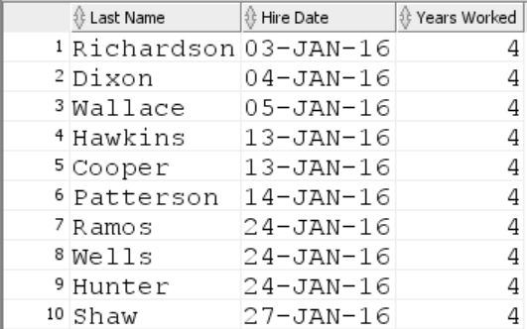

-- **Q5:** Display each employee’s last name, hire date, and the review date, which is the first Tuesday after a year of service, but only for those hired after January 1, 2016.

* Label the column REVIEW DAY.
* Format the dates to appear in the format like:  
   TUESDAY, August the Thirty-First of year 2016

You can use ***ddspth*** to have the above format for the day.

* Sort by review date

The Query returns 107 rows. See the first 10 rows of the output result for comparison.

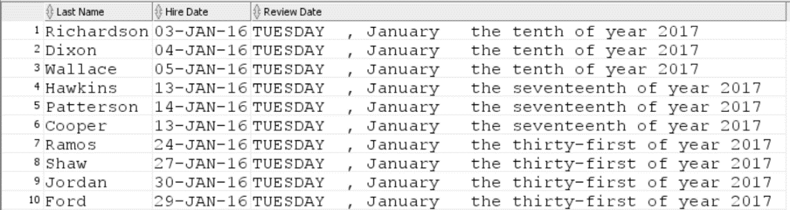

-- **Q6:** For all warehouses, display warehouse id, warehouse name, city, and state. For warehouses with the null value for the state column, display “unknown”. Sort the result based on the warehouse ID.

